Web Design Worksheet & Evaluation

In this document is your planning document for web design, it includes templates for you to use and an Evaluation Sheet.
Save this document as:- your_name_web plan.doc

(You need to complete this booklet) the teacher will view this as a print out or from your files on your computer – each stage MUST be completed by you and checked by the teacher)

Web Page Title or Project Title:

Your name:

The contents of this Web Design Worksheet have been set out according to the Technology Process –which involves Investigating, Devising, Producing and Evaluating. By completing it in detail you will be demonstrating some of the fundamental requirements of the Student Outcomes.

Note: Your final achievement level will be a combination of your
Investigation, Devising, Production and Evaluation NOT just the final product.

These (Blue) are notes only the worksheet (Black) starts soon

Investigating
  - target audience answer - Section 2 below
  - purpose of the website answer -
  - what the website will do answer -
  - benefits of an online presence. answer -

(Identify the requirements, issues, values, needs and opportunities associated with this task)
Identify the:
- Topic
- Target audiences characteristics
- Key design considerations (Design Principles) answer - Section 3 below
  - Devising (Purpose of the website - Describe your ideas, alternatives and opportunities)
Produce:

- A Time Plan
- A Content Map
- A Hierarchy Structure Chart
- A Navigation Map
- The Home & Template Screen Layout plans
- Use the Prototype Storyboard (Splash page screen layout design)
- User Documentation
- List Resource Records / Bibliography
  - Producing (What the website will do- products, processes, systems, services, environments)
Identify and justify:

- Selected software tools
- Production techniques and sequence

  - Evaluating (Explain the benefits of an online presence. intentions, plans, actions, consequences)

Web Design Worksheet Proposal

1. Technology to be developed
(What are you trying to produce, describe your web site?)

In order to produce a website for a travel agent you must have particular specifications so that the website will appeal to viewers and customers in every type of aspect. This will occur through the design elements and design principles that you will choose in order to produce a product of some sort (such as a website, logo or banner) to attract the audience. The product must attract the viewers and customers in a travelling agent website because the audience will be purchasing and handing over important details such as personal information, credit card information and other significant minutiae. You must have sufficient design elements to create a beautiful and attractive website. These design elements and design principles will include colour, form, line, shape, texture, contexture, typography and of course value. With these design elements and design principles, the audience and viewers are able to identify key aspects of this website and also consider in purchasing or investing in this particular travel agent company. The website must have identification of alignment or else you are unable to position and decide on the correct objects and also positioning these items. It entirely depends on the target audience, but I recommend using bright colour to recognize to the audience/viewers that this travelling agent website is somewhat significant. By using bright colours will attract the audience and may convince them it to purchasing tickets to particular destinations that our travelling agent company has to offer. In order for people to be convinced into handing over their details the website must be very sufficient and adequate; if it was not suitable and deceitful the audience/viewers would most probably without doubt, not purchase or take any particular interest in this website. Also if the website was not suitable in presenting their products they have to offer, the company would get a bad name for itself, meaning that no one will recommend purchasing or investing in this travelling agent. So these are the reason why the website is one of the most important features of the companies’ aspects.

2. Key Target Audience Characteristics:
(eg. Age; Gender; Interests; Pre-requisite Knowledge; Motivations; Language, Wealth, etc.)

The chosen target audience of the website for the company “Fly By Night Travel” is targeted at people that would be classified as mature, wealthy, young adults, rich older people, double income earners with no children interested in travel. As you are able to see all these categories put together is basically pretty much everyone. This makes the producer think on how and what they are going to use (such as colour and images) to let all of these categories to be appealed to the website in some sort of way. In order to appeal to these target audiences you must use design principles and design elements that will attract to the intended viewers. The intended audiences for this particular website will have to be aimed and situated from the ages of 16-65 years old. This is quite a difficult situation, but the best solution is to keep to one base colour for the background of the website, instead of having many different colours as it would most probably confuse the viewers and this will affect customers from purchasing or providing interest into this particular travel agent company. The text that should be used so that the target audience will appeal to the website I am going to use a very plain and simple font. I am most probably going to use Calibri as it is the Microsoft 2007 Word default font so most of the viewers and customers will already have been experienced to this typescript. The photos and images that will be viewed on the website will most probably appeal to all categories of the target audience. These images that will be displayed are pictures of the destinations that will be provided for viewers to purchase and travel to. This will appeal to all target audiences as it would get them a feel of what their holiday destinations would look like that they are interested into travelling to. This will prevent and relieve them form dong further research of the particular destination.

3. Key Design Features (Compare to two other company websites (travel))

Insert images and annotations below of two other sites:-
Uses the colour red throughout the whole website as it will appeal not only to one particular target audience but too many. The colour red is also very bright which will stand out and appeal to the audience. There are no other types of colours displayed on this web page which will not confuse or puzzle the elderly that view this page/website.

Site 1
The company logo is displayed in the top left corner of the webpage which would have been planned using the design principle known as alignment.

A very simple and easy format to book a destination/trip or even just checking what flights are available and what the travel agent company has to offer.

A lot of white space is displayed and identified in this website which is not a good situation in many types of business related websites.

Displayed on the top of the screen is a very basic and simple toolbar for the viewers to navigate easily.

An image of a holiday destination, which will appeal to the audiences as they are able to see what their intended holiday destination looks like. This picture is an abstract which will most probably catch the attention of the audience that views this website
The font that is displayed is very simple which is suitable for all of the target audiences. It is created in a font which can be easily read and identified. It is a large size which is suitable.

Site 2
Uses the colour sky blue throughout the whole website as it will appeal not only to one particular target audience but too many. Sky blue is also sufficiently bright which will stand out and appeal to the audience. There are no other types of colours displayed on this website, all there is, are other shades of blue (both darker and lighter). The producer has done this by increasing the contrast of the colour, through various programs
The company logo is again displayed in the top left corner of the webpage which would have been planned using the design principle known as alignment. This is so the customers are easily able to view the logo without being distracted by images and other forms of graphics that are displayed on the webpage
An image of a holiday destination, which will appeal to the audiences as they are able to see what their intended holiday destination looks like. This picture is an abstract which will most probably catch the attention of the audience that views this website. Websites display these images so they are able to view some of the landmarks that they may view during their required holiday destination.
A very simple and easy format to book a destination/trip or even just checking what flights are available and what the travel agent company has to offer. This is a much more simple process than many other travel agent companies’ websites and this will suit those that are not as technological with computer as others that are.
By presenting an image of a trophy that the company has been awarded proves that this particular company has had experience and must be a well known company over the world. By having this piece of evidence will attract the viewers and audience and most likely persuade them into contacting and interacting with this travel agent business.
There is not a lot of white space that is displayed on this particular website which is great because there are a lot of aspects where the viewers are able to be appealed too. This is a great situation for businesses that are trying to promote their company (as displayed in this particular situation).
There is not a lot of white space that is displayed on this particular website which is great because there are a lot of aspects where the viewers are able to be appealed too. This is a great situation for businesses that are trying to promote their company (as displayed in this particular situation).
Displayed on the webpage is a very simple navigation process which is not as complex as many others. This would prove that it is an ease to navigate through this particular website. This would suit those once again who are not very technological and are not as talented as others with the use of a computer.

(eg. What key features will you build into your website technology and why.)

Design Elements | Design Principles | Highlight Which Elements you will use – include notes why below
Colour | Alignment | In order to create a website promoting a business/company or product, you must use the most important design principle known as colour.
Form | Balance | Without colour you are unable to attract the audience and viewers that view your website. Colour identifies the companies’ logo and also the mood and density of the actual website itself.
Line | Contrast | Colour identifies different target audiences. Brighter would be more suitable for teenagers and also young adults while dull colours would be more appropriate for the elder and middle aged people
Shape | Dominance | Purple and pink is use to attract females while blue and red is use to attract and appeal to males.
Space | Harmony | You would use alignment to organise the website so that everything that is displayed on the website including items all look straight and formal.
Texture | Proportion | Also alignment is used to make the website look unique and suitable so that people are able to purchase and hand over their personal information to the required company.
Typography | Proximity | If the website does look unsuitable for this process to occur the customer will definitely not purchase anything from this website or hand over their personal information such as credit card number.
Value | Repetition | Alignment is a form if a design principle
 | Rhythm | Contrast is also an important type of a s design principle as in many websites that I have analysed, contrast is an important factor.
 | Style | In some of the websites viewed (referring to the Jet Set website), there were many shades of the same colour. Some were bright and the others were darker.
 | Symmetry | Contrast is used so that people (being the viewers) are able to be attracted to the colours that are displayed on the website
 | Unity
 | White Space

4. Societal / Environmental Considerations
(eg. What societal or environmental factors might effect the development of your technology and why? – laws, boundaries, beliefs, conservation, health, employment, deskilling etc)

Well, when designing a website for a company there are many laws that may interrupt with the process of creating it. The first interruption that may occur is the designing of the logo. There are many logos that have been designed for various companies around the world. Most of these logos have been copyright infringed. This makes the producer of the logo think wisely on how they are going to design their particular logo. If a logo is copyrighted infringed and it is replicated, a major penalty can occur, which will lead to a major fine. Also when inserting images onto websites, the image can be copyrighted infringed and if you insert one of these images onto a personal website without getting the permission of the owner, charges will also apply. If the producer of the website would like to insert a slogan of something they may resemble something about beliefs that may be offensive in some sort of way, the company will suffer through the laws that may convey and have dignity in beliefs and the right for all beliefs and cultures to be respected. In some cultures, a number of colours may harm these cultures in an offensive way. Before applying a colour to your website you must make sure that the colour does not offend in cultures in a particular way. If you did not do this research before applying these colours to your website the company may lose many potential and interested customers. If the producer does makes sure that what they are producing is not copyrighted infringed or offensive to any culture, they can produce a beautiful and attractive website that will appeal to many people. These are some societal and environmental considerations that you should apply when producing a website.

5. Other Circumstances Affecting Production Techniques
(e.g. What other factors might effect the development of your technology and why? e.g. Mass Production Techniques, Marketing, Delivery, Budget, Time availability)

In order to maintain a website there is a lot of maintenance and care that must be taken place. This may include by using a process to save money which is known as budgeting. As it is obvious, it cost quite a tremendous amount of money to maintain a website. Many people ask themselves, how would maintain a website cost money? Well the answer to this is that programs that are used to create and manage websites regularly order the owner to upgrade to newer and more complex editions. And to do this it cost a lot of money. Such programs such as Dreamweaver are very expensive if you go for the more complex edition. Also there is not much time available for people to keep updating these particular programs. So that leads onto my second point that there is not enough time available. Budget will affect the company or business if there is not enough money to maintain websites due to the fact they are always updating. Time is also a major factor when updating the website. This is because
Web Design Worksheet Files & Folders

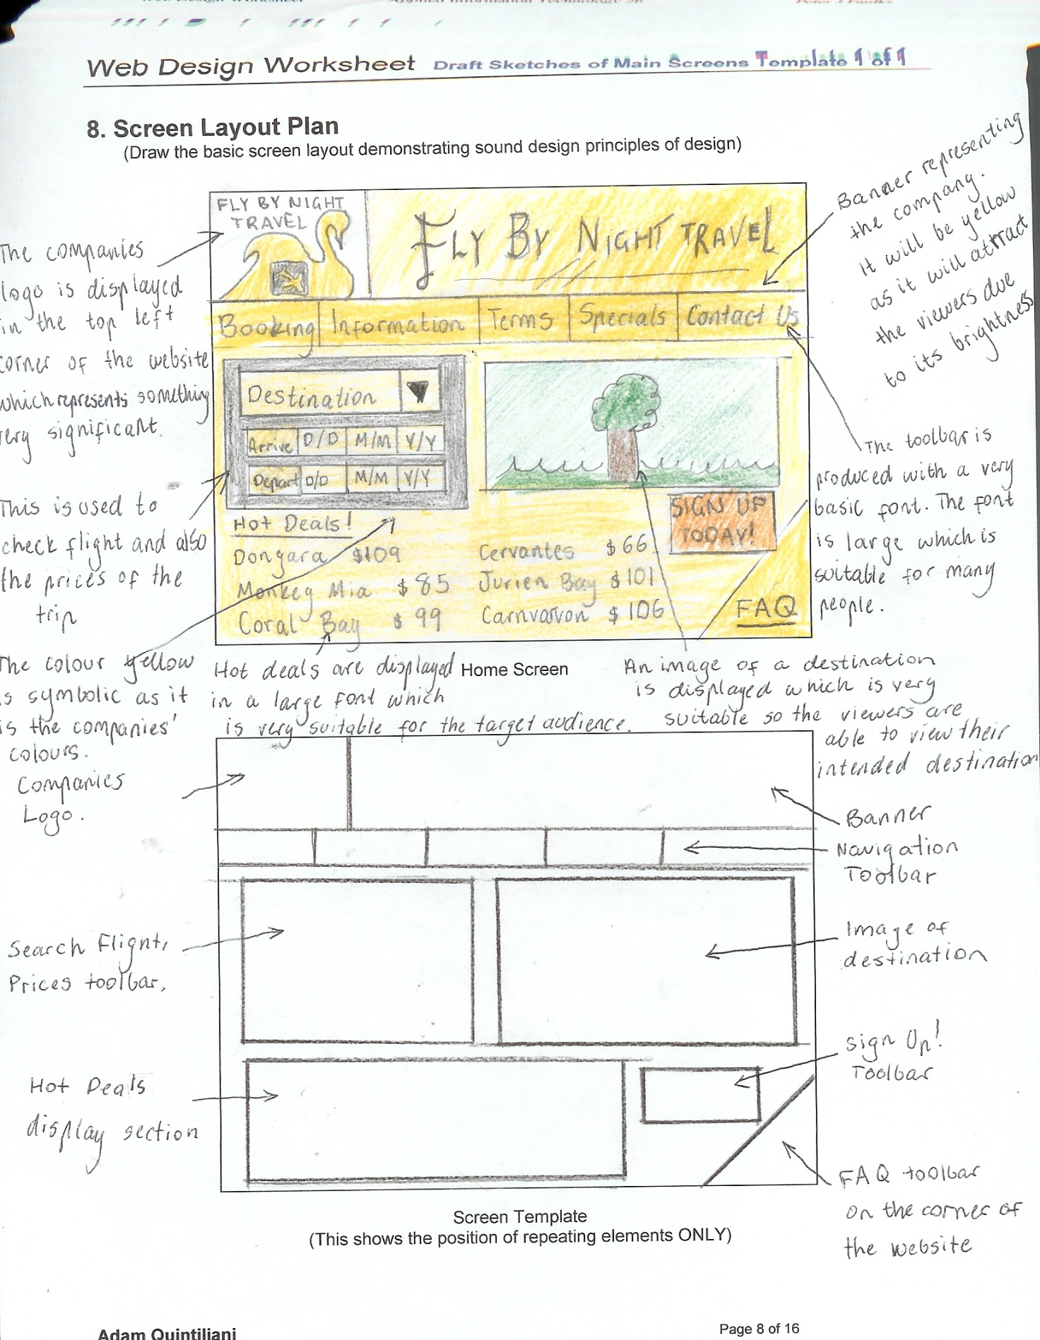

Web Design Worksheet

Application Form Screenshot:

13. Production Techniques and Sequence
(Throughout the construction of your product you should keep a daily LEARNING LOG. Use this to indicate specific production techniques and the sequence of events ie. Did you follow your initial time plan?)

14. Daily Learning Log (Who did what if a group?)
(Make a comment each day about your learning experiences, problems and solutions. This can be using the electronic learning log. A sample is shown below – make more rows as required)

Journal or Time Planner Template 1 of 2

Name
Day | Date | What I Did | Problems | Solutions
Friday | 13/08/10 | Question 1: Technology to be produced
Sunday | 15/08/10 | Question 2: Key Target Audience
Monday | 16/08/10 | Question 3: Key Design Features | Finding suitable design principles was a problem that I faced during this particular question. | Took my time finding the correct principle needed to expand on my situation.
Tuesday | 17/08/10 | Question 4: Societal/Environmental Considerations | Comprehending the context and understanding of this question | Asked and got the proper understanding from my peers.
Wednesday | 18/08/10 | Question 5: Other Circumstances Involving Technology
Thursday | 19/08/10 | Question 8: Screen Layout Plan
Monday | 23/08/10 | Question 5: Content Map | Understanding the concept on what to do for this question | Ask for guidance from my friends in class
Tuesday | 24/08/10 | Logo Designs, Final Design of Logos
Wednesday | 25/08/10 | Storyboard, Question 10: How did you plan?
Thursday | 26/08/10 | Question 12: Software, Evaluation | Thinking ahead for what programs I may have to use for the upcoming task | Thought very carefully and considerate
To add more rows
(Right mouse click – insert rows below)

Make a journal for each member if in a group

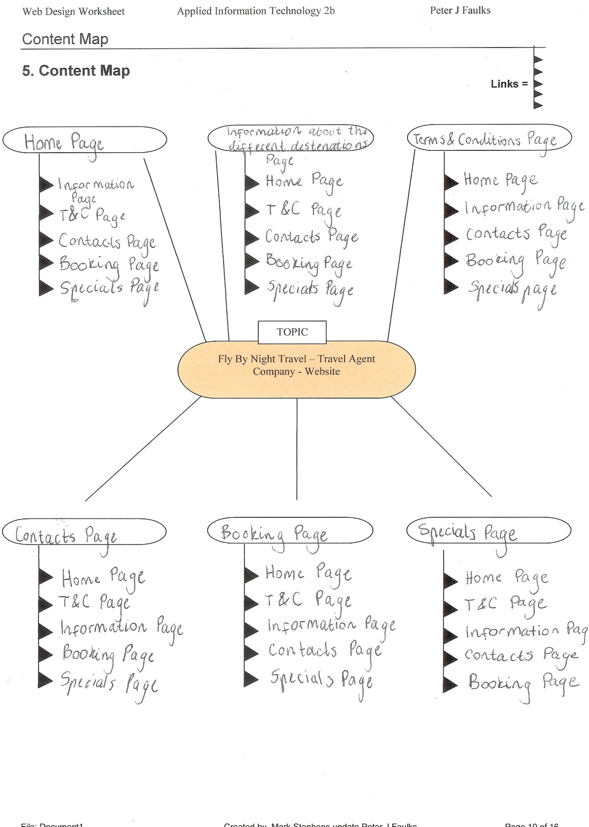

Logo Designs

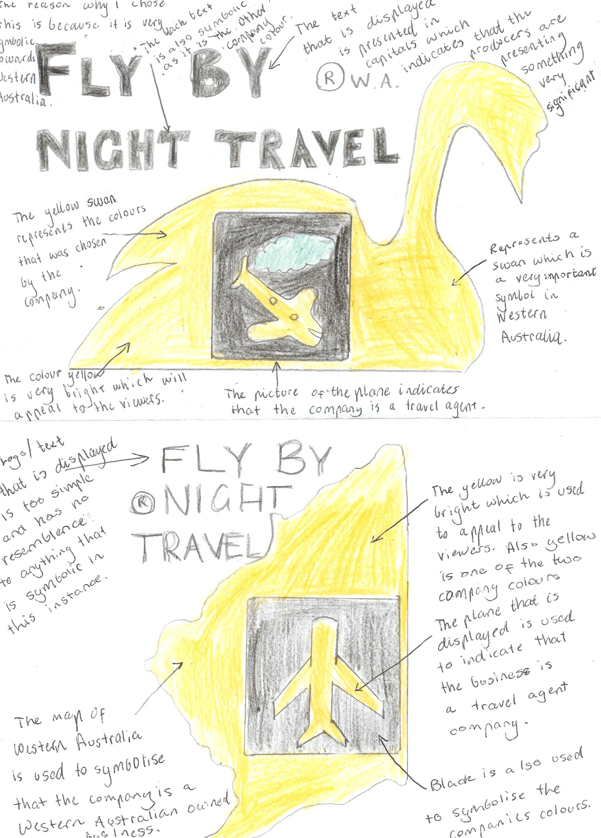

Final Copy of Logo Design:
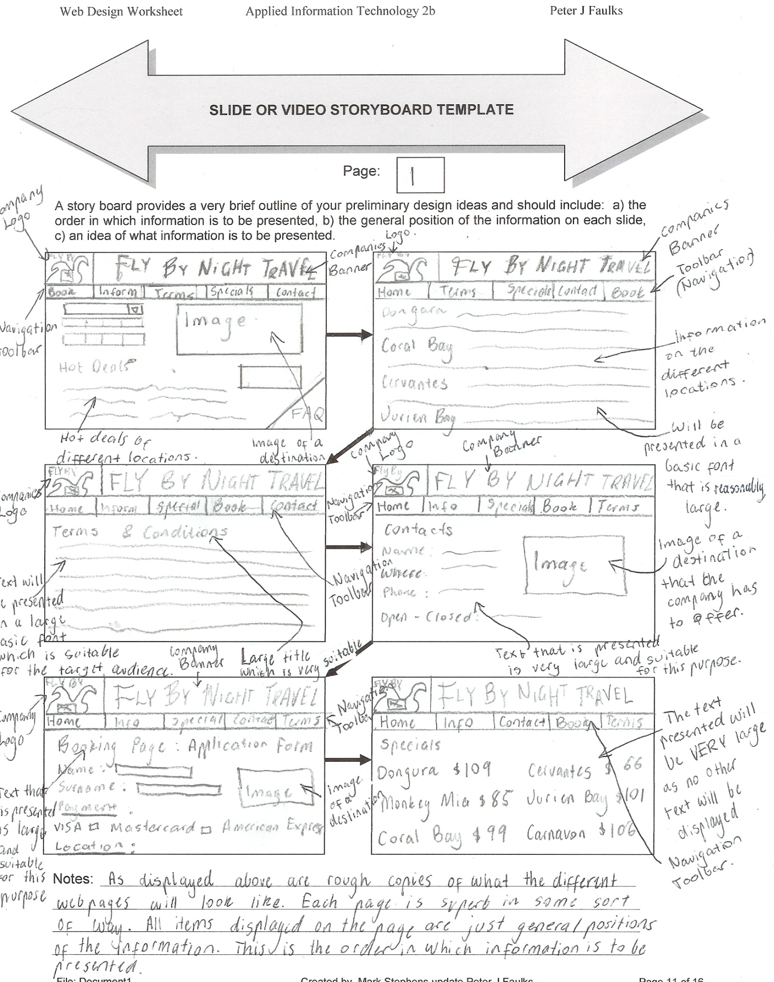

Another Copy of Storyboard
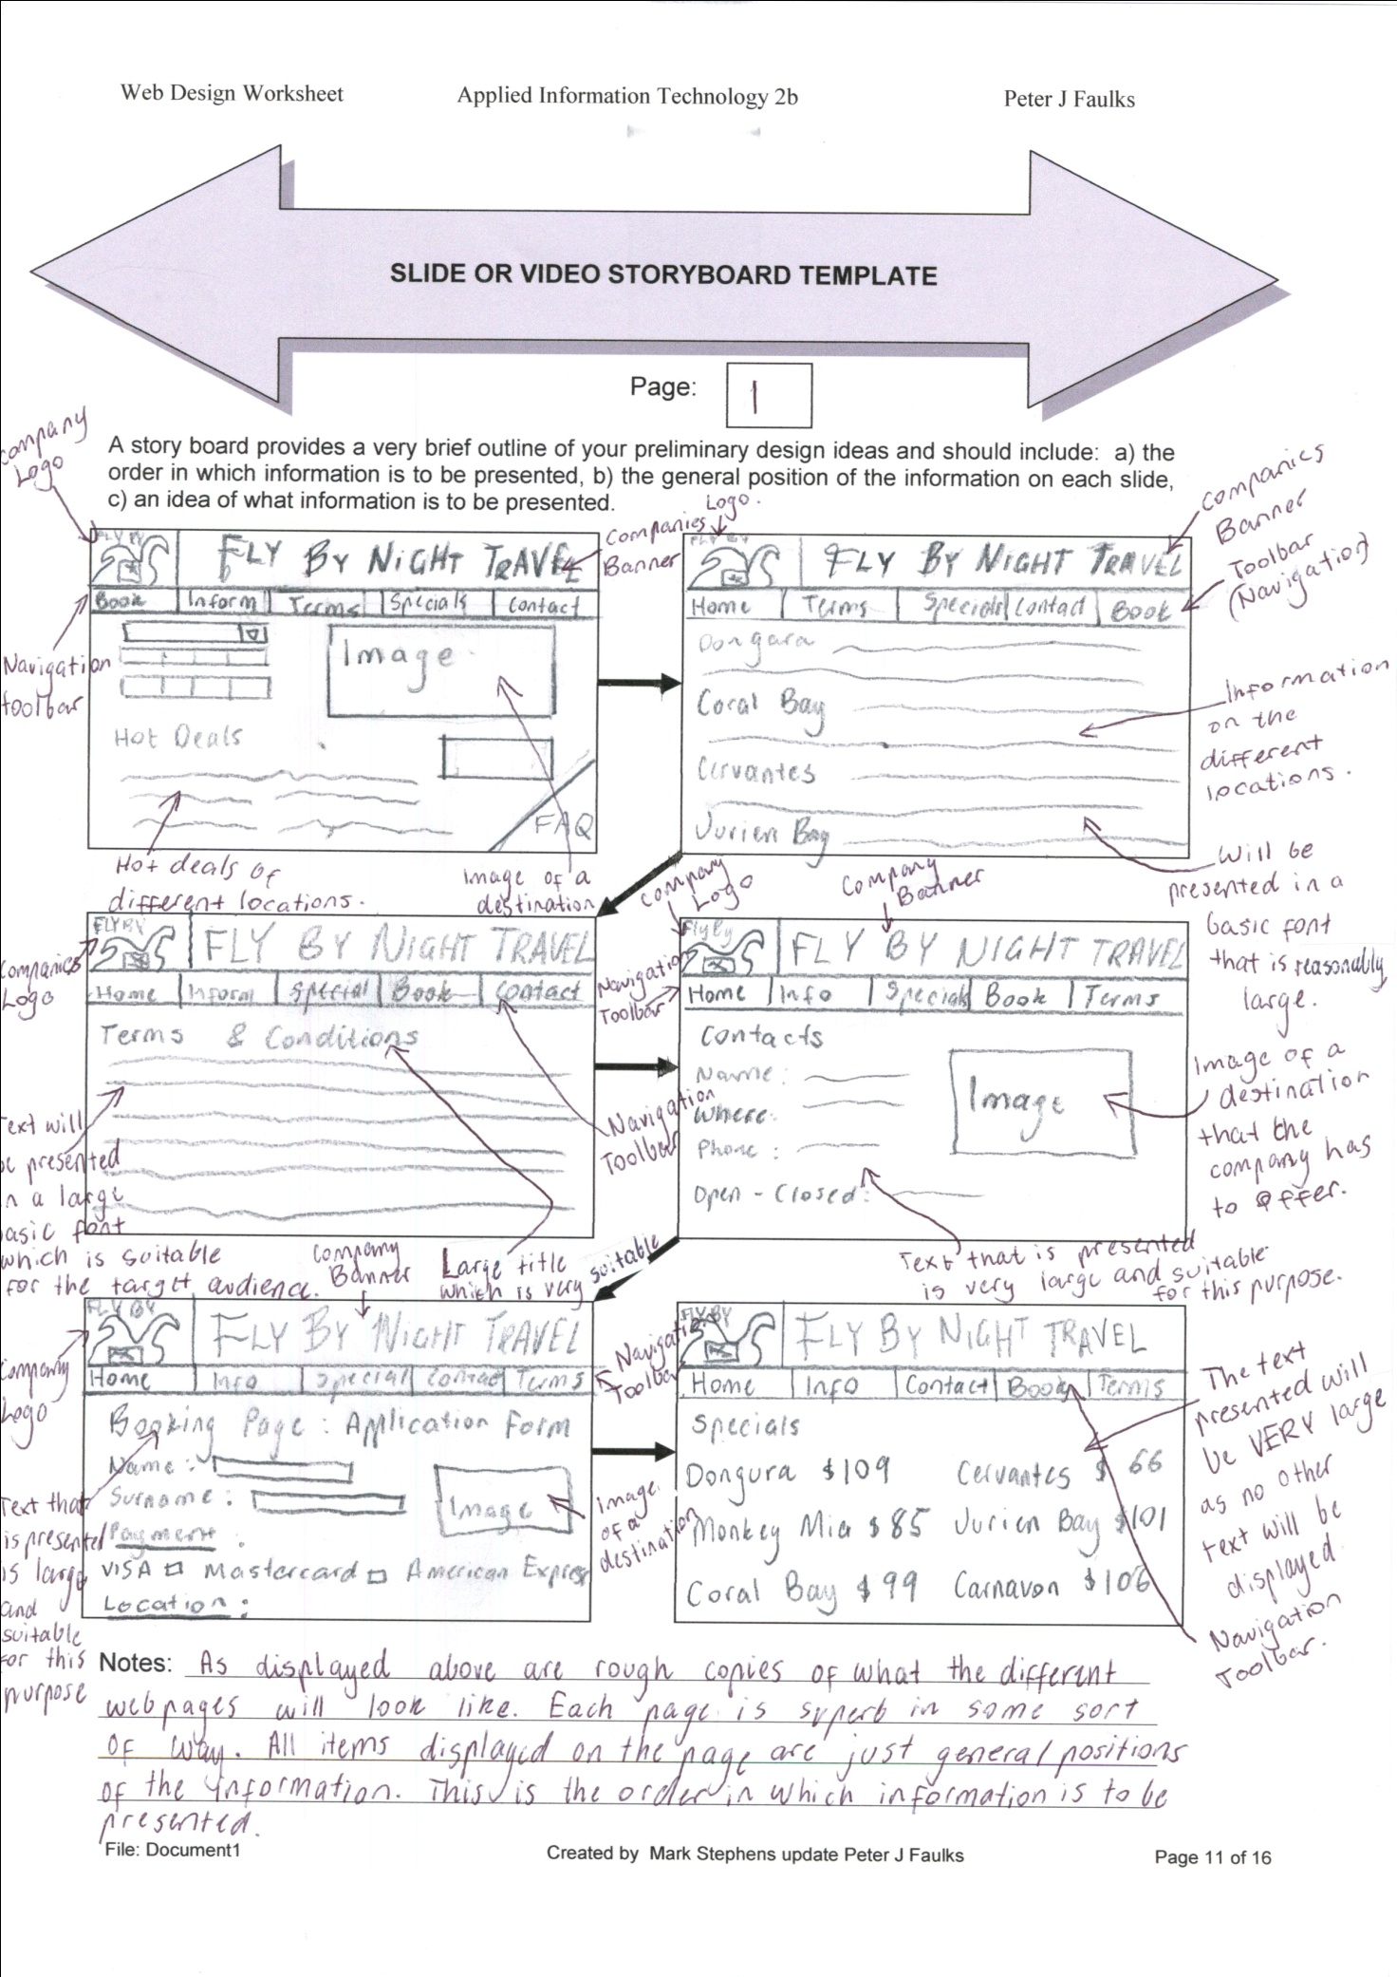

Application Form Screenshot:
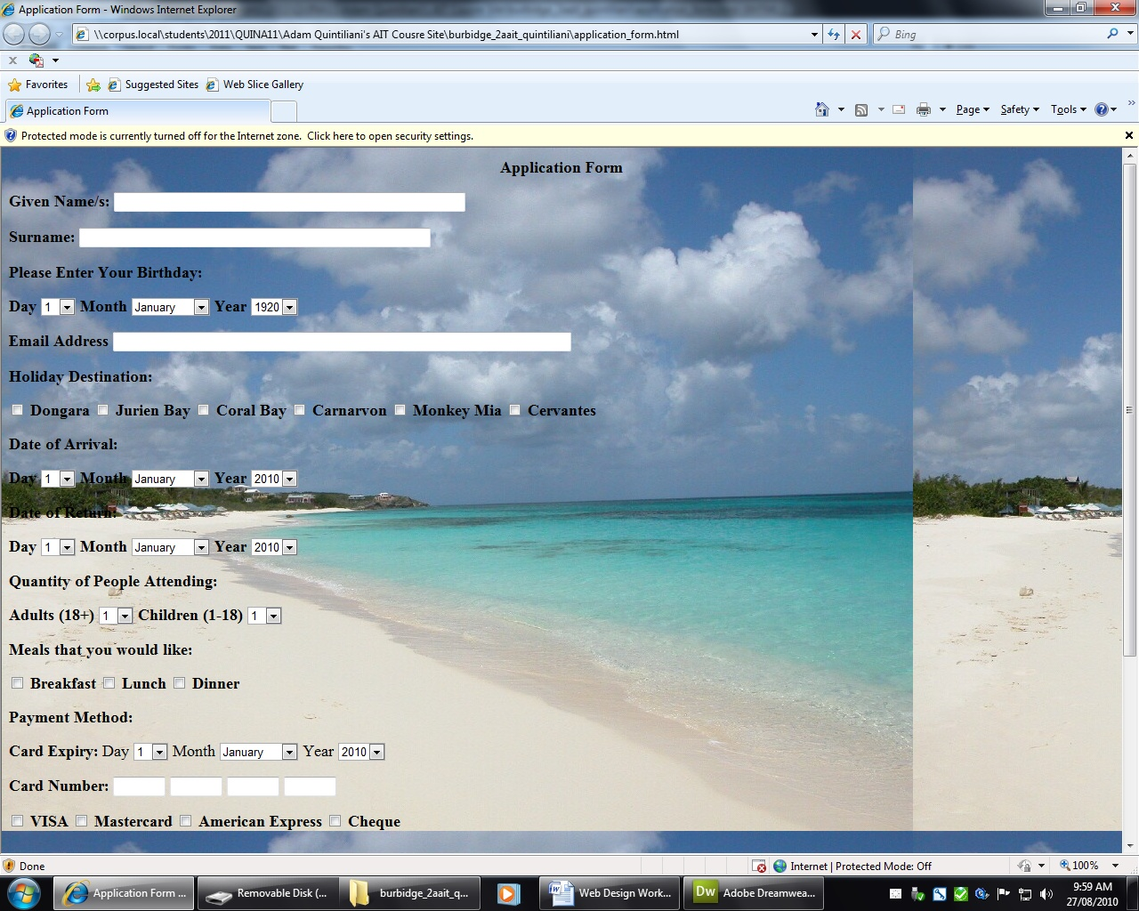Web Design Worksheet Evaluation Sheet

10. What did you do to plan this web page
(What support information will your target audience need to effectively use your product?)

details:

If the target audience want to effectively use the product, they will be able to send an enquiry form to the business which will allow them to ask question about the business or regarding the prices or even regarding the history or more information about the destination that the company has to offer to the customers and viewers of the website. The benefit of completing this process is that the enquiry customers are able to ask questions and the owners of the business will answer straight back. This particular process is very similar to the electronic mail system (known as e-mail). This process is very quick and also reliable.

Have you provided On-screen Help how = details:

In order to provide on screen help, I (the producer) am able to set up a frequently asked question page where people are allowed to send me their question about enquires and then I am able to send them an answer back and also produce it and display it on the website, so if other people have similar questions they are able to answer them for themselves by reading the frequently asked question page. The icon for this process will be located on the bottom right corner of the webpage. This is very convenient for those people who are not as technological with computers and do not know how to search a website by using the navigation toolbars.

11. Resource Record - Bibliography
(What resources have you or do you intend to use to create your product? You should have at least one from each of the following categories)

People: (Name; Position; How found)

Mr Peter Faulks, Applied Information Technology Teacher, School Teacher

Mr Meme Thinn, Applied Information Technology Teacher, Relief Teacher

Mr John Burbidge, Applied Information Technology Teacher, School Teacher

Electronic Resources: (Web Sites, CD-ROMs, On-screen Help, Tutorials, Videos etc)

add more lines

1. http://www.flightcentre.com.au/
2. http://www.jetset.com.au/
3. http://idolator.com/wp-content/uploads/2009/04/2-dolphins.jpg
4. http://www.indiantourmate.com/images/beaches.jpg
5. http://www.westernaustralia.com/au/Pages/Welcome_to_Western_Australia.aspx
6. http://www.tripadvisor.com/AllLocations-g255101-Places-Western_Australia.html
7. http://www.qantas.com.au/
8. http://www.virginblue.com.au/

Web Design Worksheet Evaluation

12. Selected Software Tools
(What software did you use to create your product. What features of the software made it particularly suitable for the way you used it?)

- Program: Adobe Photoshop CS5

Reason for use: To create the images that will be displayed on the webpage also known as a website. This program can reformat images as well as creating new images that represent the company in a sort of way. On this program you are eligible to design images with your chosen colours (in this particular company yellow and black). This is a very significant program you are able to manipulate already existing images that will suit you and the purpose of it. I have used Photoshop to create my computer generated design of the company’s logo. When I was using this program, I found it very easy to control and manage. The navigation of this program is very simple, while it is able to produce a magnificent website.

- Program: Adobe Dreamweaver CS5

Reason for use: This is used to create and manage your website that you have created and functioned. This process is a type of a design as you have to create the website and they are not already pre created. Dreamweaver is a very significant program as you readily have to update as there hardly any types of new releases. This helped to create my application form that I have print screened in one of the above pages.

- Program: Flash Professional CS5

Reason for use: This program will be used to create graphics that will be animated. These will include animations such as banner which will be displayed in the pages of the website. This particular program is used to attract the customers and viewers that view this website. This results in the customers taking interest into this particular website as well as promoting it to friends and family. This is an important program for the promotion and publication of the website.

Task Evaluation

Consider your task carefully and critically evaluate your work by answering the following questions.

1. What was the purpose of your task?
Answer: The purpose of the task was to create a plan for the website that we will be creating in the next task. I have investigated already existed websites and produced ideas from these websites.

2. Who was your intended audience of your newsreader background?
Answer: The chosen target audience of the website for the company “Fly By Night Travel” is targeted at people that would be classified as mature, wealthy, young adults, rich older people, double income earners with no children interested in travel

3. How well do you think your design suits the intended audience?
□  Very well | □  Quite well | □  Not sure | □  Could be improved | □  Audience not considered in the design

4. Have you been able to test your design on someone from your intended audience group?
What was their reaction?
Answer: Yes I did, and I was told that it was a great design plan for my soon upcoming design. I was also told that I am able to improve on a few things, and this is not using as much yellow as I displayed.

5. How many samples were you able to view to help you investigate your design?
□  None | □  1 or 2 | □  About 5 | □  Between  5 and 10 | □  More than 10

6. How did you decide which software to use for your background?
□  I produced several versions in different software and chose the best | □  I did some drafts in a couple of applications and chose the best one to complete it in | □  I began using one application and swapped to another when my skill levels increased | □  I only used one of the suggested applications | □  I only tried word processing software

7. How original was your design?
□  I copied a design I had seen elsewhere | □  I copied a design and changed the colouring and shapes | □  I used a variety of designs and combined different aspects of them | □  I used a variety of ideas as inspiration and then developed my design | □  Completely original

8. Did you produce and keep draft copies of your background and your written response?
□  Yes, my pencil and paper drafts are in my hardcopy portfolio and my digital copies are in my electronic portfolio | □  Yes but only a digital draft version | □  Yes but I only kept a hardcopy draft | □  Yes I did but I didn’t keep any copies | □  No, only a final copy

9. Are you happy with your image manipulation skills at this stage?
□ Yes □ No
Explain
Answer: I am very happy with my image manipulation as I spent quite a bit of time to produce my images that I was influenced and manipulated.

10. Would you like to develop your skills in image manipulation further since completing this task?
□ Yes □ No

11. Did you find any restrictions to your ability to manipulate your images?
Answer: No, I kept focused to what I had to do and completed it with ease and enjoyment. I enjoy designing logos and manipulating images and photos.

12. Did you check your task for spelling and grammar mistakes?
□ Yes □ No

Why / Why not?
Answer: I checked it because when handing in an assessment you must make sure that you have suitable grammar or else you may get penalised if the marker does not comprehend on what you are trying to say, argue and produce.

13. How did you feel about your time management for Task 1?
□  I need a lot more time to finish my event item properly | □  I spent more time than suggested in preparing my event item | □  It took me about the same time suggested in the course to complete my event item | □  I was able to work quite quickly and had some time to spare | □  I worked very quickly and was able to spend time refining my item through learning more application tools
14. Have another look at the Scenario and the Task outline. Do you believe this item (this booklet) meets the requirements of the task? Explain
Answer: Yes, I do believe it does meet the requirements of the task, as it follows all aspects that were required in order to complete this task. It contains all aspects and more that is great and significant to the fact that a lot more can be completed to the necessary requirement. The destination page is not displayed individually but it is displayed in the storyboard and is annotated in great detail. The screen template is a template of the home screen which will be displayed in the final production of the website.

4. Rate yourself in the boxes below on the following criteria

AIT (Level 4, 5, 6 or 7)
- For each box  Rate Your score in each based on the following: | Satisfactory High Very High
 | 4 | 5 | 6 | 7

                - Type your score here

Ability to locate information & research without any assistance | 7
Shows initiative | 6
Leadership/Planning Qualities | 7
Application to the task | 6
Time Management | 5
Works without any ‘nagging’ from the teacher | 7

- Did you personally enjoy investigation of your task?

Answer:

Yes / No Why: Yes I did enjoy this particular task. With the techniques of the websites that I analysed I was able to complete my own draft of a website that had relevance to the topic that we were given. This came out quite successful I believe. I have enjoyed this task very much and have learnt a lot from it. I am very excited in actually completing this task to my intended time plan. I am very excited for the upcoming task where I out my plans to the task and actually create the website that I have planned with detail.

- What are some things you liked / disliked about this task?

Answer: I found it very intellectual investigating travel agent websites that already exist. Analysing these websites gave me ideas where I was able to compile my knowledge to create a website by myself. There weren’t many things that I disliked about this task but I did not enjoy that fact that there was many questions that are was unable to comprehend and had to complete it with the best of my knowledge. These questions included question 4 and 5. I did manage to answer these question but with a bit of difficulty. This was probably the most difficult section of my whole assessment.

Present this worksheet for each phase starting with your proposal…

If as a printed copy - it will be regularly returned to you during the task for updating.
or Saved on the Thumb Drive - Electronically and checked by the teacher. It should include”

- Proposal
- Draft Ideas –hierarchy
- Storyboard
- Journal
- Evaluation

